Drew Gonzales
4/30/2023
Professor MARK LERH
PROJECT 1
ADVANCED OBJECTS
CIS-17B

SUMMARY OF ITERATIONS AND GENERAL CHALLENGES:

NUMBER OF LINES AND VARIABLES IN THE GIVEN PROJECT:

- main.cpp:
  - Total lines of code: 207 (including comments and whitespace)
  - Number of functions: 1 (timetracker)
  - Number of variables: 9 (choice, USERNAME, PASSWORD, ADMINP, loggedIn, totalTime, user, admin, ADMINACTION)
- user.h:
  - Total lines of code: 56 (including comments and whitespace)
  - Number of classes: 1 (User)
  - Number of functions: 4 (loadUser, getUserStatus, changePassword, createUser)
  - Number of variables: 2 (username, password)
- admin.h:
  - Total lines of code: 89 (including comments and whitespace)
  - Number of classes: 1 (Admin)
  - Number of functions: 3 (loadAdmin, getUserStatus, createAdminAccount)
  - Number of variables: 2 (username, password)

Project 1: Basic Time Tracker
Iteration 1: Design and Basic Functionality
- Define the project scope and main features.
- Design the basic structure for User and Admin classes, and a structure for user information.
- Implement a simple menu for user and admin actions.
- Implement basic sign-in functionality for users and admins.
- Implement a timer to track the duration of a user's session.
Challenges:
- Work on clearing up the issues with the user validation and along with changing the time tracker
- Trying to implement the switch cases effectively and building the logic of the header files for USER.H and ADMIN.h to assure that their implementation is done correctly
- Assuring that the reprompts happen over and over again with the while loop
Iteration 2: Enhancements and Error Handling
- Improve the sign-in process by handling invalid credentials and adding error messages.
- Implement the ability for users to change their passwords.
- Implement the ability for admins to create new admin accounts, view user accounts, and delete user accounts.
- Add error handling for file operations and user input.
Challenges:
- Handling various edge cases and errors in user input and file operations.
- Ensuring data integrity when reading and writing to binary files.
- Issues with the time tracker not working correctly and attempting to resolve it
- CASE 6 for deleting the data and the logic itself not being totally correct(this would be revised in version 3).
Iteration 3: Refactoring and Optimization
- Refactor the code to improve readability and maintainability.
- Optimize the code to minimize redundancy and improve performance.
- Test the application extensively to ensure it works as expected in all scenarios.
- Document the code and write a summary of the iterations and general challenges.
Challenges:
- Identifying areas of the code that can be refactored and optimized.
- Ensuring that the refactored code maintains the desired functionality and performance.
- Thoroughly testing the application to catch any potential issues or bugs.
Summary of Iterations and General Challenges:
Throughout the three iterations, the main challenges involved designing a robust and efficient structure for the time tracker application. The focus was on handling various user scenarios, file operations, and data integrity issues. Furthermore, in developing this project for each iteration I needed to set out a basic template in order to understand how to make a construct for how the time tracker would work. Conventionally, it was not implicitly clear what the process would look in order to make an effective time tracker or what it would take. The first step was just to reuse the code and slightly tweak it from the group project and then modify a few basic cases. One of the challenges involved was removing the inessential code from the ADMIN.h file along with the USERS.h file. This was somewhat difficult since I had to remove and eliminate functions that were not inherently useful or beneficial. Thus, the first objective was to make 2 header files one called USER.H and then another called ADMIN.H. This general process involved using the header files and then using an import structure called #include <name of file> to incorporate the name of that given file. Then for iteration 1.0 I simply went through the code templates and remove any unnecessary functions. It is worthy of noting I also split the structure definition into common.h just to make the code as simple and as organized as humanely possible. The next objective was devising a mechanism to iterate through each choice and to make a robust time tracker menu. Thus, I simply created multiple cout statements to make prompts for the user then and then used loggedin= false in order to indicate when the loggedin is true or boolean false. This allows the computer to keep track of when the user loggin is valid or invalid. The next objective, was to simply use switch cases from 1-5 that would correspond to the list of choice gives. In version 1.0 I simply added the basic functionality along with the timtracker function. In this version we used a header include file chrono file that allows you to track the time accordingly. In this given version, the time tracker was not not functional and did not store values. Furthermore, the sequential order was not correct for the switch cases as I had switch case 0 at the bottom when it should have been at the top for the given login. It was logically out of sequence. The other problem was getting the ADMIN account to load correctly and I also had to remove a few non-essential method functions that did not belong in this given project. In version 2.0 the code was not working totally, I simply did more debugging adde the and tested the input validation and ended up having issues with the login for the user not working correctly. This was eventually resolved because I realized the binary file info for digits was not working correctly. In reality, what needed to occur was that their needed to be a modification to assure only string values occurred. When I put string values then the code worked otherwise perfectly as long as I did not put tons of digit values it seemed to create significant problems going forward. I also added switch case 6 and where I attempted to add a friend function since I was having issues with private member class access which kept causing issues in this code. Then, I wrote the basic implementation for trying to delete the binary file but the code was imperfect when I realized that it was a requirement for all assignments for the admin to query from the database. Thus, in this version I simply left it broken, since I did not have enough time to fix it to my liking . The only modifications I made to ADMIN.h was simply adding a loadadmin function since the user.h file did not seem to load the admin correctly. Otherwise, the other 2 header files stayed mostly the same I would say. Finally, in version 3.0 I simply continued to work on the logic in the MAIN.CPP and had issues with the USER.H file in that it did not seem to work so I eventually deleted it and then did away with the friend function implementation and rewrote it all over again since it did not seem to work correctly. Furthermore, I ended up deleting all the binary file and then recreating it because the data that was stored in the binary file seemed to not be reading correctly which seemed to be what was responsible for the user accounts to not being read accordingly. I am not sure why this is the case but it seems when you put a numeric value and string values into a binary file into a long enough sequence it seems to have a problem with it and does not read it correctly for some reason. Furthermore, I redid the entire USER.H function since I could not deduce where the logic mistake was at. Next for case 6 I changed the input and added a while loop and changed a few naming conventions to assure that the readability for this given code was high and efficient as possible. Furthermore, I used getlines instead of cin to assure that the file would be read correctly along with all the whitespace inbetween. This is the main difference between cin and getline is that cin does not necessarily read all the whitespace which can make it harder to read from a file consistently or to query any relevant string values. The only other thing I did was add multiple if else if statements for deleting the account and then creating a temporary outfile which would then rewrite to the binary file and change the value of the strings that exist inside of the binary file. This would override the existing string value and remove the one that no longer needed to exist. This also has roughly 2-3 if else conditionals that assures that if the improper string value is added that there is a catch all prompt statement given to the user to know that they did not put in the proper input. Additionally, there is also an option for the ADMIN to VIEW ALL RECORDS Which will output all the values of the binary file so that the ADMIN can view everything or they can alternatively view a user value one by one as necessary. Next, I added a user validation for ADMIN to assure that if the admin or an account user is not logged in then you cannot actually access the database accordingly. This entire implementation was not super long but the main issue was trying to read from the binary file correctly which involved me having to delete the binary file and then repopulating it with proper values to assure that it reads correctly for both the user and the given admin accordingly. Otherwise this project fulfills the majority of the functionalities of the required assignment, it tracks time, it allows for admin and user login but it does not store string values over 8-9 strings which eventually will yield an error of sometype. It is unclear to me why this is the case as I did not have sufficient amount of time to debug this in a comprehensive manner accordingly.

CONCLUSION:
I would say if I had more time I likely would try to work on trying to fix and revise some of the prompts because it does not totally validate for when the ADMIN attempts to login in. Their also exists issues for the USER as well once the binary file stores values beyond 8 string values within the binary file as I reiterated earlier . Furthermore, I would say that it's important the time tracker could also benefit for simplification and possible more functions in other files so that the code is not so long in the main.cpp would be hugely beneficial going forward. Otherwise, this project was done to the best of my ability and I will say that it does the majority of the things that you want it to do. In the future it might be best to only assign one project rather than two because the functionalities for 2 projects makes it significantly harder to manage both of them at the same time which can be come overwhelming at time.

THIS IS THE FLOW CHART

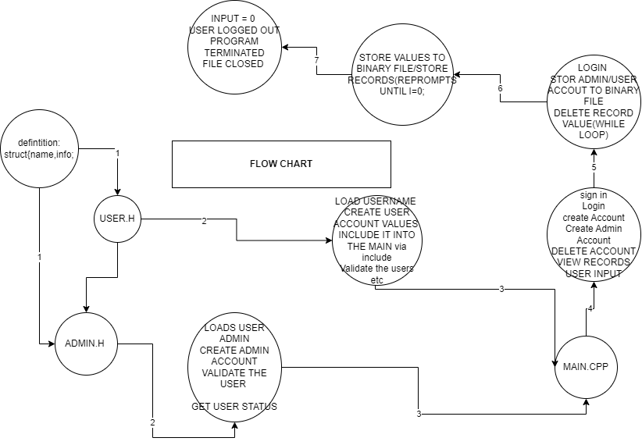
PURPOSE: This flow chart shows the general flow of how the program should run. First, there are the existing header files which push their functionalities to the main.cpp. The main cpp creates a set of various prompts that the user can enter then you can do proceed to a login. This follows by either storing those given values into the binary file followed by a termination of the program once the user enters the value 0. I added 2 more circles to show the intermediate step of the import of the circles and their extra functionalities that are included into the main.cpp so that you are aware of what functionalities are included when they are imported into the main accoridngly.

THIS IS THE UML DIAGRAM

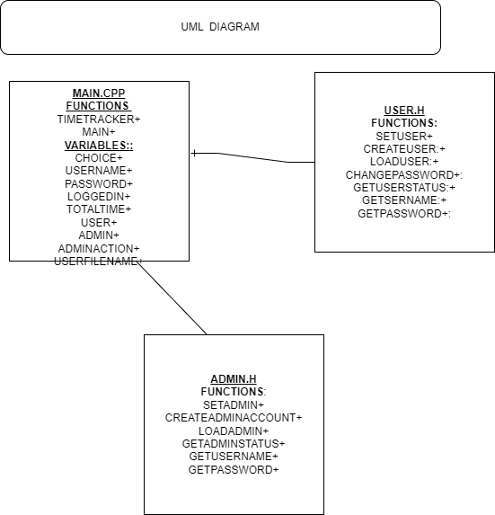
PURPOSE: THIS UML DIAGRAM SHOWS THE DEPENDENCY RELATIONSHP TO THE MAIN.Cpp file, I've also listed all the relevant variables and functions that exist within each of the header files and in the main CPP. The header files are imported into the main cpp using the include operator which allows for the extra functionalities of the program such as admin creation, user creation user login and much more.

